EXPT NO 7.1 Monitoring HTTP and HTTPS packets using Wireshark

Objectives
1. To capture and analyze HTTP packets using Wireshark and observe the transmission of data over an unsecured communication channel.
Software Requirements
- Wireshark
- Web Browser (Google Chrome/Mozilla Firefox)
- Internet Connection
Websites Used
HTTP Website
http://testaspnet.vulnweb.com/login.aspx
Theory
HTTP (Hypertext Transfer Protocol)
HTTP is a protocol used for communication between web browsers and web servers. It transfers data in plaintext and does not provide encryption. As a result, transmitted information can potentially be viewed through packet monitoring tools.
Procedure
Part A: Monitoring HTTP Traffic
Step 1: Open Wireshark and select the active network interface.
Step 2: Click Start Capturing Packets.
Step 3: Open a web browser and access:
http://testaspnet.vulnweb.com/login.aspx
Step 4: Enter sample credentials:
Username: student
Password: admin123
Step 5: Click the Login button.
Step 6: Return to Wireshark and stop packet capture.
Step 7: Apply the following filter: http
Step 8: Observe:
- HTTP GET requests
- HTTP POST requests
- Request headers
- Response headers
- Form submission details
Output:

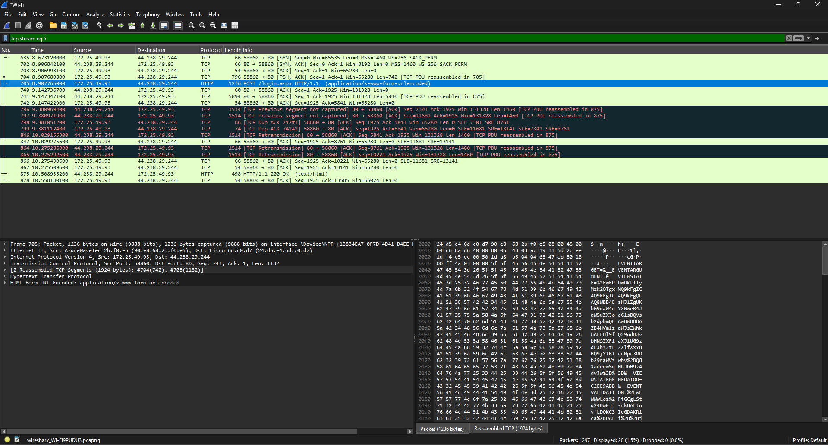

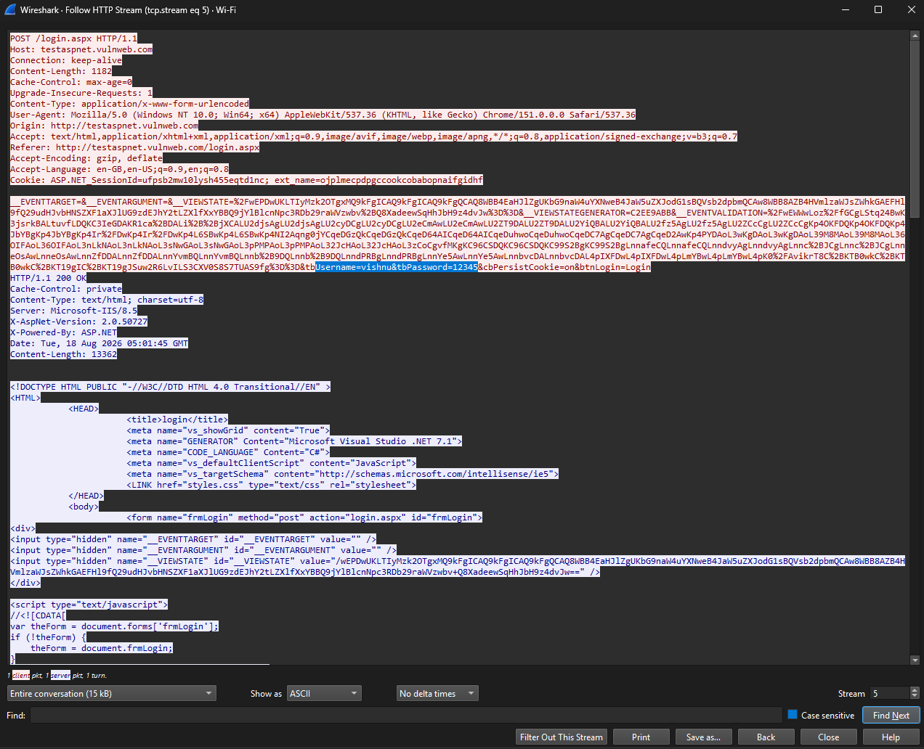
Objective 1: HTTP Traffic Analysis
Username entered | Password entered | Username detected | Password detected
PRATHIP RAJ K | 12345 | PRATHIP RAJ K | 12345

Result
Objective 1: HTTP Traffic Analysis
HTTP traffic was successfully captured and analyzed using Wireshark. The HTTP requests and responses were visible in plaintext, allowing the transmitted data and packet contents to be inspected. This demonstrated that HTTP does not provide encryption for web communications.

